DEV BHOOMI UTTARAKHAND UNIVERSITY

ASSIGNMENT ON JFET(JUNCTION FIELD EFFECT TRANSISTOR)

SUBMITTED BY:

KHUSHI KUMARI TODI

BTECH(CSE),SEC A

22BTCSE0217

SUBMITTED TO:

DR.SANDEEP SHARMA SIR

TRANSISTOR:-The transistor was invented by Dr.William Shockley and Dr. John Laboratory in America in 1951.First time, in 1952 transistor was used in telephone switching circuits.Since then ,it has revolutionized the field of electronics.

DEFINITION:-The transistor is a basic building block of all modern electronic systems.It is a three terminal device.The output voltage,current or power are controlled by the input current in a transistor.Therefore,it is also called a current-controlled device.

It is of two types:

(i)BJT-BIPOLAR JUNCTION TRANSISTOR

(ii)FET-FIELD EFFECT TRANSISTOR

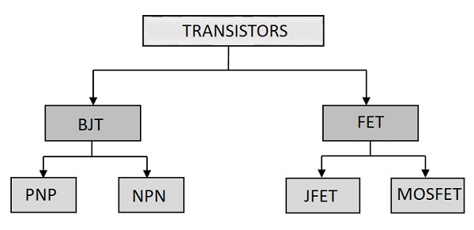

Here,we will discuss about JFET.

JFET is known as JUNCTION FIELD EFFECT TRANSISTOR.

JFET are three-terminal semiconductor devices that can be used as electronically controlled switches or resistors,or to built amplifiers.

It is of two types:

(i)N-channel JFET.

(ii)P-channel JFET.

N-channel JFET

It simply consists of an N-type semiconductor bar with two P type heavily doped regions diffused on opposite sides of its middle part.The P-type regions form two PN-junctions.The space between the junctions (i.e.,N-type regions)is known as channel.It has three terminals:-Gate,Drain and Source.

* Both the P type regions are connected internally and a single wire is taken out in the form of a terminal known as the Gate(G).
* The electrical connections (known as ohmic contacts) are made to both ends of the N-type semiconductor and are taken out in the form of two terminals known as drain(D) and source(S).
* The drain(D) is a terminal through which electrons leave the semiconductor bar and Source(S) is a terminal through which the electrons enter the semiconductor.

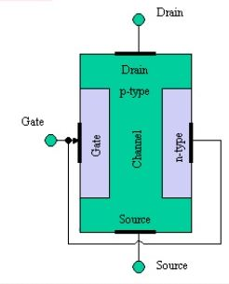

WORKING OF N-CHANNEL JFET

When V(DS) is applied between Drain and Source terminal at zero gate voltage ,between the two junction established depletion layer/region on the PN junction.The electrons will flow from Source to Drain through the channel between the depletion layer,the size of these layer determine the width of the channel and the current conduction also.

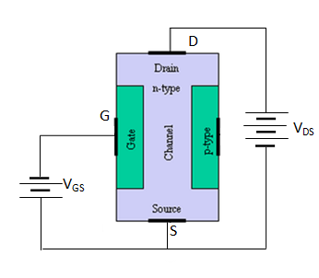

* When reverse voltage V(GS) is negative,applied between Gate and Source

The width of the depletion layer increases,this reduces the conducting channel,therefore increases the resistance of n type substrate.Consequently,current from Source to Drain is decreased.

On the other hand,if the reverse voltage is decreased,the width of the depletion layer also decreases,width of the channel increases and Source to Drain current also increases.

There are two basic operation of JFET

* When V(GS)=0,V(DS) increasing to some positive value
* V(GS)<0,V(DS) at some positive value
* Pinch off voltage:-It is the minimum Drain to Source voltage at which Drain current becomes constant.It is denoted by (vp ).

SYMBOL of N-channel and P-channel JFET

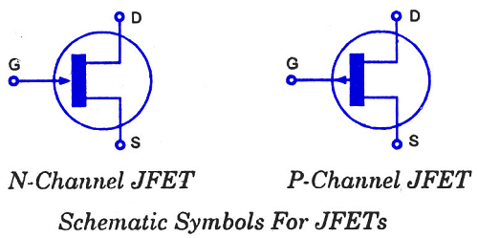

Graph of N-channel JFET

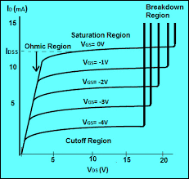

ADVANTAGES OF JFET OVER BJT

The FET enjoys several advantages over the conventional bipolar junction transistor(BJT).Some of them are listed as under:

* It is a unipolar device so its operation depends on the flow of majority carriers only.
* It is relatively immune to radiation.
* FET has a very high input resistance(typically few megaohms).
* FET is less noisy.
* It does not exhibit any offset voltage at zero drain current hence it can be used as an excellent signal chopper
* FET has a better thermal stability.

APPLICATIONS OF JFET

* It is used as a switch.
* It is used as a buffer.
* It is used as a chopper.
* These are used in oscillatory circuits.
* These are used in cascade amplifiers.

Thankyou